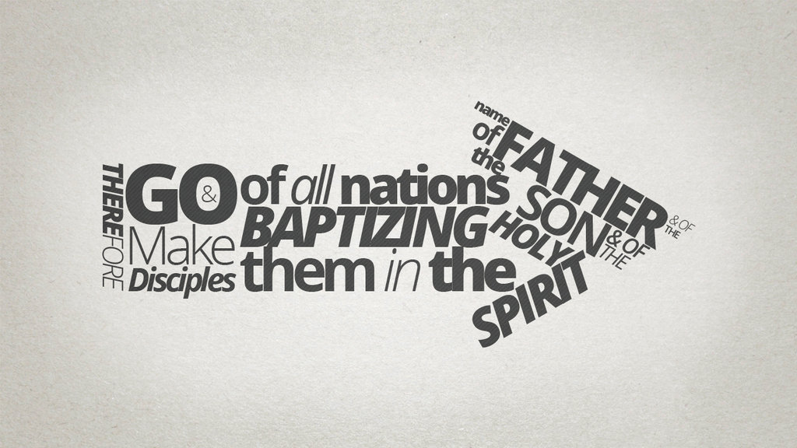  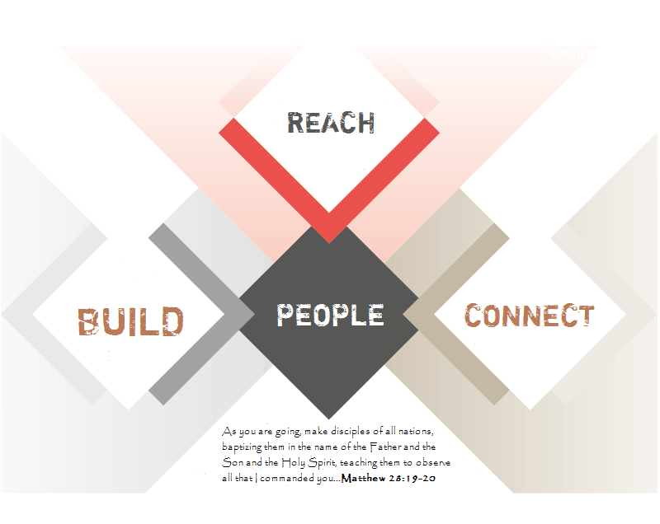 |  |  | Quick Note…  Thank you for visiting our church today. We are so excited to get to know you as you get to know us. Allow me to take a moment and introduce you to our Sunday School Connection Groups. Each Connection Group is designed to help you grow in your spiritual walk with Jesus Christ. We exist to REACH out, BUILD together, and CONNECT in ministry. We believe these groups help you establish lifelong relationships while building your faith and trust in God. For more information on our Sunday School Connection Groups, please feel free to contact us or visit us online.  Have a Jesus filled day!  James Oney  Minister of Adult Education and Discipleship  Contact Us  Kelly Golden  Education Secretary  Phone: 334.792.9406  Email: kgolden@rbcdothan.org  Web: www.rbcdothan.org  RIDGECREST BAPTIST CHRUCH  1231 Fortner Street  Dothan, AL. 36301 |  |  | 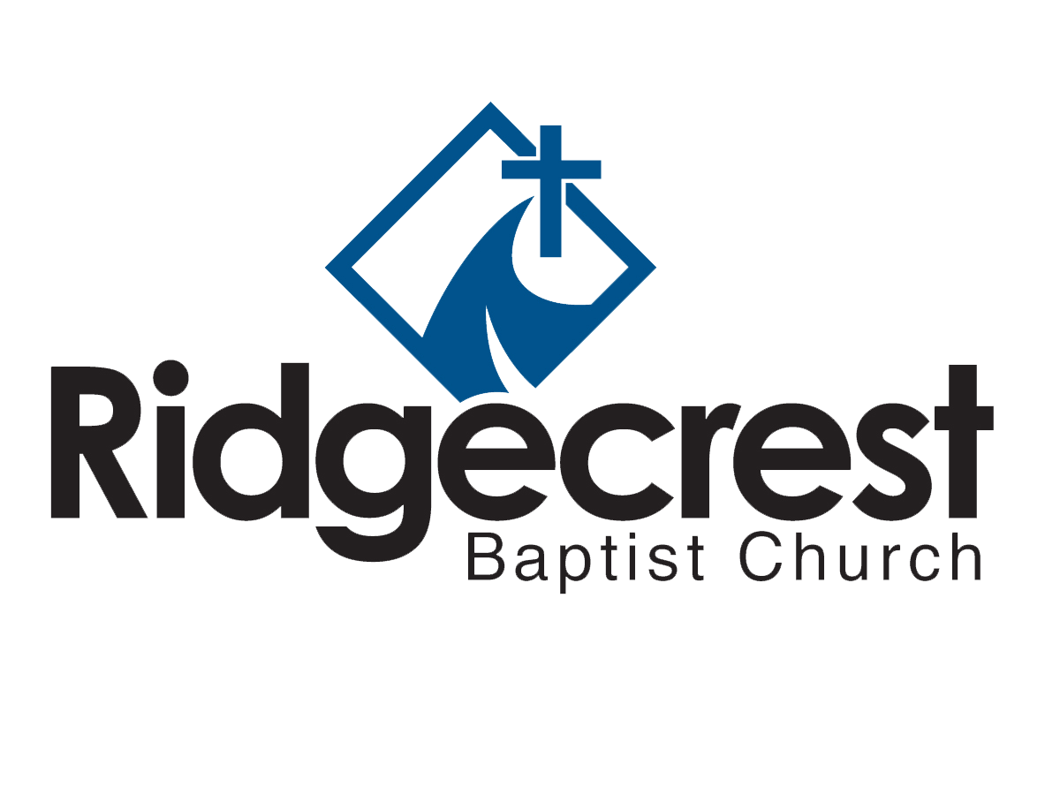  WINTER/SPRING 2016  SUNDAY SCHOOL CONNECTION GROUPS

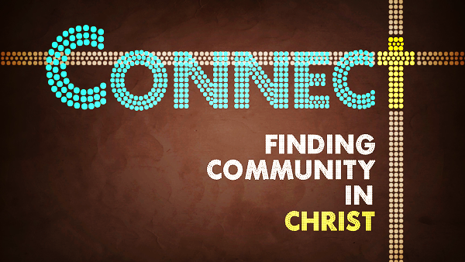  CONNECTION  GROUPS  PRESCHOOL  Birth – Two Preschool West  Threes – Fives Preschool East  CHILDREN  1st grade boys Willis/White E215  1st grade girls Odom E214  2nd grade boys Shivers/Scott E212  2nd grade girls Arnold/Beck E213  3rd grade boys Golden/Miller E211  3rd grade girls Franklin/Bush E207  4th grade boys Brown/Bush E209  4th grade girls Hammond/Heard/Moye E208  5th grade co-ed Holloway/Hollis/Adams E216  YOUTH  6th grade Bruner/Wiggins/Summerlin E202  7th grade boys Thomaston/Jeter Aerobic  7th grade girls Cumbie/Hall Track 2  8th grade boys Mills/Stevens Craft  8th grade girls Stevens/Davidson Track 1  9th grade boys Kinney/Gannon E221  9th grade girls Jeter/Pearcy E220  10th grade boys Peterson/Bruner E201A  10th grade girls Spry/Willeford E201C  11th grade boys Oswalt/Spry E221  11th grade girls Watkins/Peterson E201B  RBCdothan.org  We exist to REACH the lost, BUILD the believer, and CONNECT Christians to serve and expand the Kingdom. |  |  | 12th grade boys Lifto/Moulton E206  12th grade girls Lifto/Smith E217  ADULTS  SINGLES  College Anderson Acts29  Career  MARRIED  w/Children  Rhodes/Murray D109  w/Children & Youth  North D104  Borcik/Champion D107  w/Youth  Nemish E218  w/Youth & College  West D106  Empty Nesters  Taylor E219  Hicks E204  Pittman E205  Various C104  Various D102  MEN Avg. Age  M. Hall D202 30  Seales/Faulk Woodland Bldg. 49  Oppert D203 Open  Cantrell C101C 79  LADIES  Turner Parlor 29  Hulsey D105 48  Vann C101B 74  Kirkland C103 76  Granberry C102 79 |  |  | Watkins C105A 81  Tomlinson C105C 86  Hillman D111 Open  Kennedy RFC Meeting Rm Open  CO-ED  Locke/Oney E203 Open  Crone D108 Open  Holloway Fellowship Hall Open  Foster C101 74  WORSHIP SCHEDULE  Sundays  Blended Worship 8:15 AM  Connection Groups 9:45 AM  Contemporary Worship 10:50 AM  Adult Choir/Orchestra Rehearsal 5:00 PM  Adult LifeGroups 5:00 PM  Evening Worship 6:00 PM  Wednesdays  Prayer Meeting/Bible Study 6:00 PM  Adult LifeGroups** 6:00 PM  Gravity (Grades 6-8) 6:00 PM  Age Group Ministries (Birth-8th Grade) 6:00 PM  Orchestra Rehearsal 6:30 PM  Choir Rehearsal 7:00 PM  Elevate (Grades 9-12) 7:00 PM  Epicenter (College/Young Singles) 8:00 PM  **LifeGroups are available Sunday-Friday. For more information about our LifeGroups, please contact our Education Office.

